**CDAC Mumbai PG-DAC AUGUST 24**

**Assignment No- 2**

1)Write a program that checks if a given year is a leap year or not using both if-else and switch-case.

package assigment2;

import java.util.Scanner;

public class LeapYear {

public static void main(String[] args) {

// **TODO** Auto-generated method stub

Scanner sc = new Scanner(System.***in***);

int year = sc.nextInt();

char c;

if(year % 400 ==0 ||(year %4 == 0 && year %100 !=0)) {

c ='a';

}else {

c ='b';

}

switch (c) {

case 'a':

System.***out***.println(year + " is a Leap Year");

break;

case 'b':

System.***out***.println(year + " is Not a Leap Year");

}

}

}

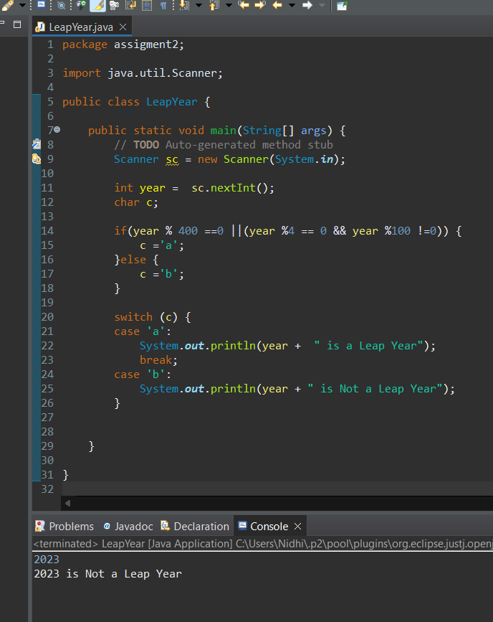

2)Implement a program that calculates the Body Mass Index (BMI) based on height and weight inpuusing if-else to classify the BMI int categories (underweight, normal weight, overweight,etc).

/*

*

Underweight: BMI less than 18.5

Normal weight: BMI of 18.5 to 24.9

Overweight: BMI of 25 to 29.9

Obesity: BMI of 30 or higher*/

package assigment2;

import java.util.Scanner;

public class BMICalculator {

public static void main(String[] args) {

// TODO Auto-generated method stub

Scanner sc = new Scanner(System.in);

System.out.println("Enter a weight in Kg :");

float weight = sc.nextFloat();

System.out.println("Enter a height in cm:");

float height = sc.nextFloat();

float bmiCal = weight/(height/100 * height/100);

System.out.println(bmiCal);

if (bmiCal<18.5) {

System.out.println("Underweight");

}else if(bmiCal>=18.5 && bmiCal<24.9) {

System.out.println("Normal wieght");

}else if(bmiCal>=25 && bmiCal<29.9) {

System.out.println("Overweight");

}else if(bmiCal>30) {

System.out.println("Obesity");

}

}

}

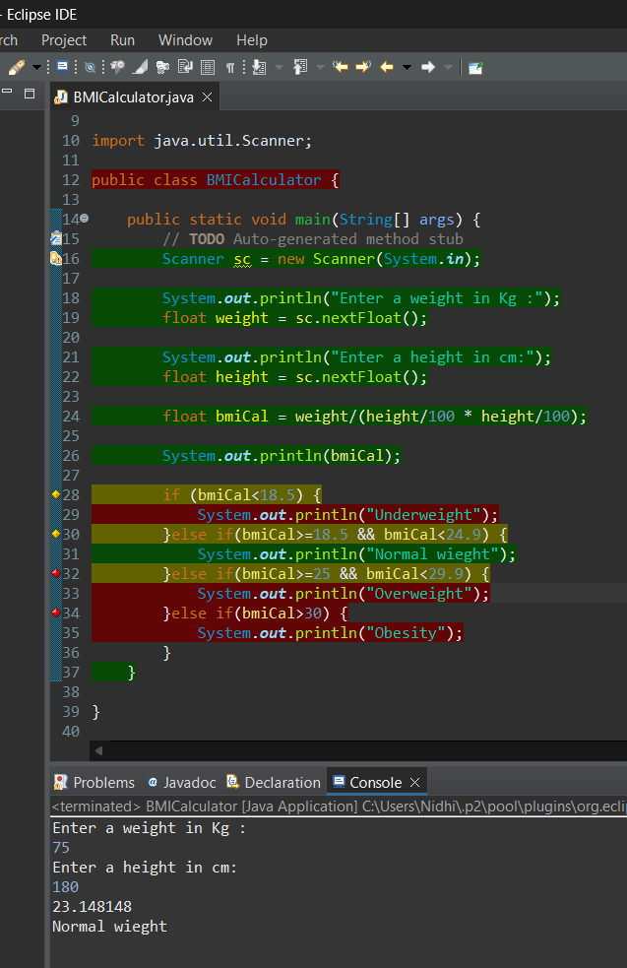

3)Write a program that checks if a person is eligible to vote based on their age.

package assigment2;

import java.util.Scanner;

public class EligibleVoter {

public static void main(String[] args) {

// **TODO** Auto-generated method stub

Scanner sc = new Scanner(System.***in***);

int age = sc.nextInt();

if(age<18) {

System.***out***.println("Not eleigible for voting");

}else {

System.***out***.println("Eligible for voting");

}

}

}

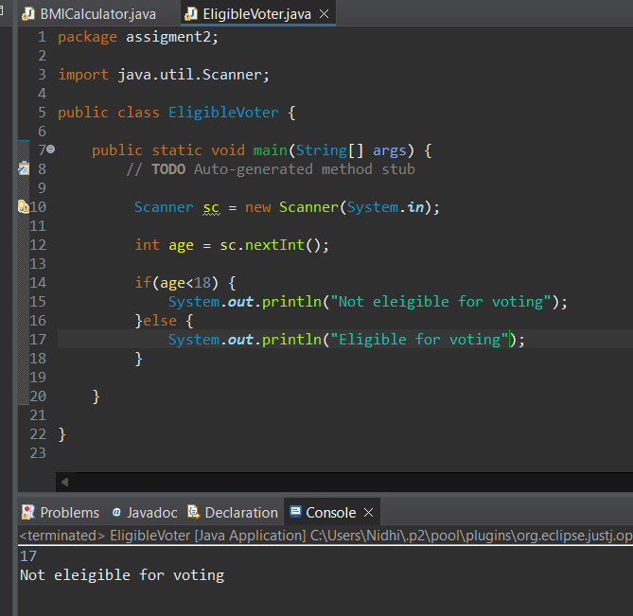

4)Write a program that takes a month (1-12) and prints the corresponding season (Winter, Spring, Summer, Autumn) using a switch case

package assigment2;

import java.util.Scanner;

public class Season {

public static void main(String[] args) {

Scanner sc = new Scanner(System.***in***);

System.***out***.println("Enter a number :");

int number =sc.nextInt();

switch(number) {

case 4:

case 5:

System.***out***.println("Summer");

break;

case 6:

case 7:

case 8:

System.***out***.println("Mansoon");

break;

case 9:

case 10:

case 11:

System.***out***.println("Autum");

break;

case 12:

case 1:

System.***out***.println("Winter");

break;

case 2:

case 3:

System.***out***.println("Spring");

break;

default:

System.***out***.println("Enter the valid month number");

}

}

}

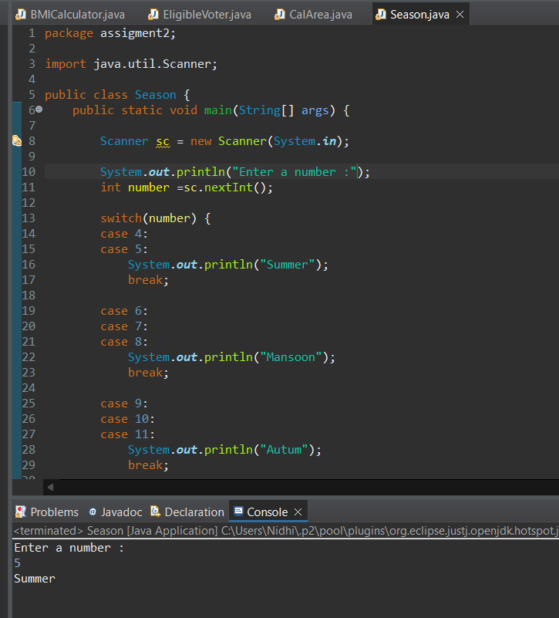

5)Write a program that allows the user to select a shape (Circle, Square, Rectangle, Triangle) and then

calculates the area based on user-provided dimensions using a switch case.

package assigment2;

import java.util.Scanner;

public class CalArea {

public static void main(String[] args) {

// **TODO** Auto-generated method stub

Scanner sc = new Scanner(System.***in***);

System.***out***.println("Enter the shape of your choice :");

String shape = sc.next();

switch (shape) {

case "Circle":

System.***out***.println("Enter the radiis of the Circle :");

int r = sc.nextInt();

System.***out***.println("Circle Area :" + 3.14*r*r);

break;

case "Rectangle":

System.***out***.println("Enetr the rectangle length :");

int lenght=sc.nextInt();

System.***out***.println("Enter the breath lenght :");

int breath = sc.nextInt();

System.***out***.println("Area of rectangle :" + lenght*breath);

break;

case "Square" :

System.***out***.println("Enter a side of sqaure :");

int s = sc.nextInt();

System.***out***.println("Area of Sqaure :"+ s*s);

break;

case "Triangle":

System.***out***.println("Enter a height of triangle :");

int height = sc.nextInt();

System.***out***.println("Enter a base of triangle :");

int base = sc.nextInt();

System.***out***.println("Area of triangle : " + 0.5*height*base);

break;

default:

System.***out***.println("Enter a predefined shape leike Sqare,Circle,Rectangle,Triangle shape");

}

}

}

